City Tours Ltd.

Shelly Cashman Access 2019 | Module 1: SAM Project 1b



Creating and Modifying Tables and Other Database Objects

# GETTING STARTED

* Open the file **SC_AC19_1b_*FirstLastName*_1.accdb**, available for download from the SAM website.
* Save the file as **SC_AC19_1b_*FirstLastName*_2.accdb** by changing the “1” to a “2”.

If you do not see the .accdb file extension in the Save As dialog box, do not type it. The program will add the file extension for you automatically.

* Open the **_GradingInfoTable** table and ensure that your first and last name is displayed as the first record in the table. If the table does not contain your name, delete the file and download a new copy from the SAM website.
* PROJECT STEPS

1. City Tours Ltd. is a company that provides tours in a city that is a popular tourist destination for travelers. As a customer service manager for the company, you've decided to create an Access database to better manage information on customers and tours. Create a new table in Datasheet View with the following options:
   1. Rename the default primary key ID field **TourNumber** and change the data type to **Short** **Text**. *TourNumber* should remain the primary key.
   2. Add a new field with the name **TourName** and the **Short Text** data type.
   3. Change the field size of the *TourName* field to **35**.
   4. Add a new field with the name **BasicCost** and the **Currency** data type.  
        
      Save the table using **Tours** as the name.
2. With the *Tours* table still open in Datasheet View, add the record shown in Table 1. Save and close the *Tours* table.

* Table 1: New Record for Tours Table

|  |  |  |
| --- | --- | --- |
| *TourNumber* | *TourName* | *BasicCost* |
| **W0101** | **House History** | **35** |

1. Create a new table in Design View to store the customers of City Tours Ltd. who have requested private group tours as follows:
   1. Add a field with the name **GroupNumber** and the **AutoNumber** data type.
   2. Set *GroupNumber* as the table's primary key.  
        
      Save the table with the name **Groups** but do not close it.
2. With the *Groups* table still open in Design View, add a second field to the table with the field name **CustomerID** and the **Short Text** data type. Save the table and then close it.
3. Open the *Guides* table in Design View and change the name of the field named *FName* to **FirstName** and use **LastName** to change the name of the field named *LName*.
4. With the *Guides* table still open in Design View, change the data type property for the *GuideID* field from Number to **Short Text**.
5. In Design View, add a new field to the *Guides* table after the *Phone* field. The field should be named **StartDate** and have the **Date/Time** data type. Save the *Guides* table and do not close it.
6. Switch the *Guides* table to Datasheet View, navigate to the fifth record (which has a *GuideID* field value of 108), and **delete** the record.
7. With the *Guides* table still open in Datasheet View, navigate to the third record (which has a *GuideID* field value of 104) and change the value to **Devlin** for the *LastName* field. Close the *Guides* table.
8. You also need to view individual guide records. Use the **Form** tool to create a form for the *Guides* table. Save the form with the name **Guide Data Form** and confirm that the form matches Figure 1. Close the form.

* Figure 1: Guide Data Form in Form View

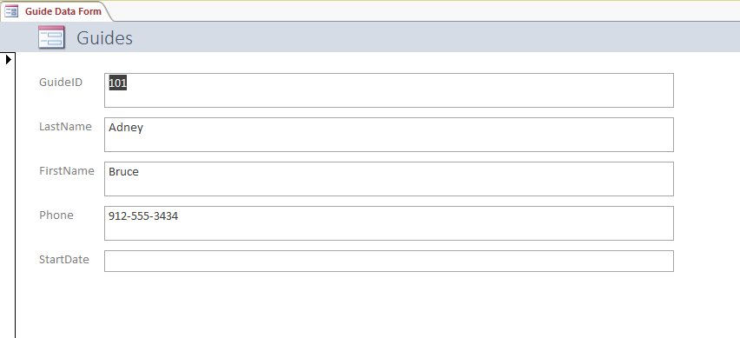

1. Use the **Simple Query Wizard** to create a query based on the *Customers* table with the following options:
   1. Include all fields from the *Customers* table in the query.  
        
      Save the query with the name **Customers Query** (which is the default name) and then close the query.
2. You need to refer to a printed copy of the *Customers* table when reconfirming tour reservations. Use the **Report Wizard** to create a report based on the *Customers* table with the following options:
   1. Include the *LastName*, *FirstName*, and *Mobile* fields from the *Customers* table in the report.
   2. Do not include any grouping levels.
   3. Sort the report by *LastName* in **Ascending** order.
   4. Select **Tabular** as the layout of the report and **Portrait** as the orientation of the report.  
        
      Save the report using **Customer Contact Report** as the name.Confirm that the report matches Figure 2 and then close the report.

* Figure 2: Customer Contact Report in Print Preview

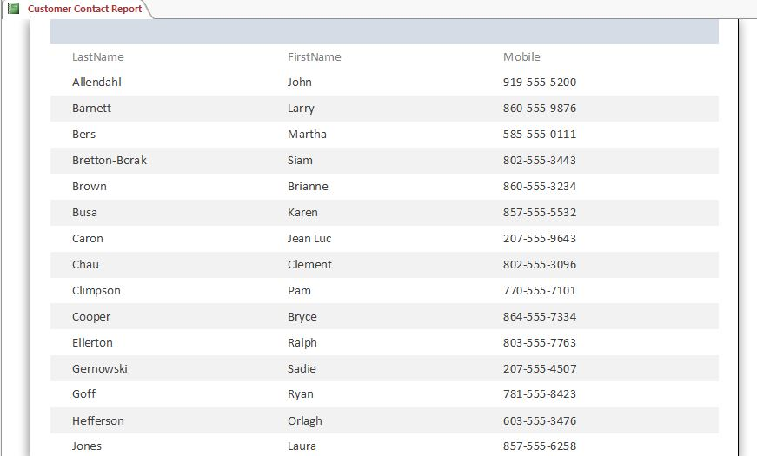

1. In the Navigation Pane, use **Customer Data Form** to rename the *Customers* Form.

Save and close any open objects in your database. Compact and repair your database, close it, and then exit Access. Follow the directions on the SAM website to submit your completed project.